Daniel Malone

Elliane Hall

Md Sayemul Islam

**Data Description**

Data from the United States Census Bureau is used to obtain information about population estimates and estimated migration rates by county. Estimates are based on collected Census Data from 2000, 2010, and 2020. The dataset encompasses a comprehensive compilation of data pertaining to 3,143 counties, covering years 2000 to 2022. Variables include data on population, migration, births, and deaths. Within this extensive dataset, individual observations were identified and documented for each county in each year, totalling 72,289 observations. The dataset is cleaned and presented at a county-year level.

Employment data is sourced from the United States Department of Agriculture, and covers the time period 2000 to 2022. The dataset includes information about the number of people employed and unemployed, the unemployment rate, and the number of people in the labor force, all at a county level. The data has information on 3,143 counties and 23 years, thus making the total number of observations 72,289. The dataset is cleaned and presented at a county-year level.

Precipitation data is sourced from the National Oceanic and Atmospheric Association, specifically the National Centers Environmental Information. The NOAA site hosts an archive of climate data gathered from 130 observing platforms. The dataset used contains precipitation data by each United States county for each year between 1895 and 2022. The data is restricted to the continental United States, so entries for Hawaii, Alaska, and the various overseas American territories were dropped. The difference between precipitation in the year of observation and the year before are calculated. Lastly, the years are restricted to the time period between 2000 and 2022, thus making 72,289 total number of observations.

All datasets were merged together by FIPS code and year, to create a unified dataset.

Our hypothesis tests the effect of droughts on population migration on a county level. Thus, the difference in precipitation between the current year and the prior year will tell us if there is consistently low precipitation in a county. After conducting some more analysis on the difference in precipitation, we will determine how many years of decreasing population will be defined as a drought. Population migration is defined as the total number of people that migrated in/ out of a county as a percent of the population in the county for each year. The data we chose is valid for testing our hypothesis because it tells us how many people are migrating in and out of a county compared to the total county population, as well as how precipitation is changing within a county over the set of years. This will allow us to derive estimates on the effect of low precipitation (droughts) on changes in population from migration per county.

The first shortcoming of our data is that it may not account for all potential confounding variables that could influence demographic changes. Omitted variables can lead to spurious correlations or incomplete explanations. Moving forward, we may want to include data on agricultural output and overall county GDP, since agricultural jobs would likely influence migration to counties with high agricultural output, and high agricultural output is likely correlated with high precipitation. Further, we assume that there will be higher migration rates to counties with higher overall county GDP. We plan to use state or county fixed effects, as well as year fixed effects, in our regressions. However, we do not think that county GDP and agricultural output would be controlled with these fixed effects.

The precipitation data we collected spans years 1895 through 2022 and the unemployment and migration data we collected spans 2000 to 2022. Due to the confinement in our unemployment and migration data, we may not capture long-term trends or the impact of events that occurred outside of the time frame. It would be ideal if we could have data for migration and precipitation spanning 1895 to 2022. Furthermore, we chose precipitation data instead of data on droughts to define whether a county is in drought. There are many different ways to define a drought, so we felt it was best to define it ourselves to create consistency. While we have not yet found the best way to define it, we will explore the precipitation data and read more literature on similar topics to find the best definition.

Lastly, precipitation patterns may not have an immediate effect on migration. There could be a time lag between changes in precipitation and changes in migration that needs to be considered. Furthermore, since our data includes information up to 2022, it's possible that our analysis may not fully capture the long-term effects of recent events like the COVID-19 pandemic, which might have influenced migration patterns. Thus, we could potentially face structural break problems in our data due to COVID-19 or other significant events.

**Variable List**

Source: U.S. Census Bureau

VARIABLE DESCRIPTION

fips FIPS code for county

year Year of observation

pop_estimates Census estimates of the population in county

pop_change Population change from prior year to current in county

births Number of births in county during year of observation

deaths Number of deaths in county during year of observation

natural_inc Natural increase in population from prior year to current in county

int_migration Net international migration in county during year of observation

dom_migration Net domestic migration in county during year of observation

net_migration Net migration in county during year of observation

residual Residual population not explained by demographic component

gq_estimate Population of people in county living in group quarters

birth_rate Birth rate in county during year of observation

death_rate Death rate in county during year of observation

natural_inc_rate Natural increase rate in county during year of observation

int_migration_rate International migration rate in county during year of observation

dom_migration_rate Domestic migration rate in county during year of observation

net_migration_rate Net migration rate in county during year of observation

fips_year Interactive term with FIPS code and year variable

migration_pop Migration as percent of population in county in year of observation

Source: U.S. Department of Agriculture

VARIABLE DESCRIPTION

fips FIPS code for county

year Year of observation

employed Number employed people in county during year of observation

unemployed Number unemployed people in county during year of observation

unemploy_rate Unemployment rate in county during year of observation

labor_force Number people in labor force in county during year of observation

fips_year Interactive term with FIPS code and year variable

Source: National Oceanic and Atmospheric Administration

VARIABLE DESCRIPTION

fips FIPS code for county

year Year of observation

precip Total precipitation for county during year of observation

fips_year Interactive term with FIPS code and year variable

precip_diff Difference in current year and previous year precipitation

**Descriptive Statistics**

Descriptive Statistics for Difference in Current Year and Previous Year Precipitation**:**

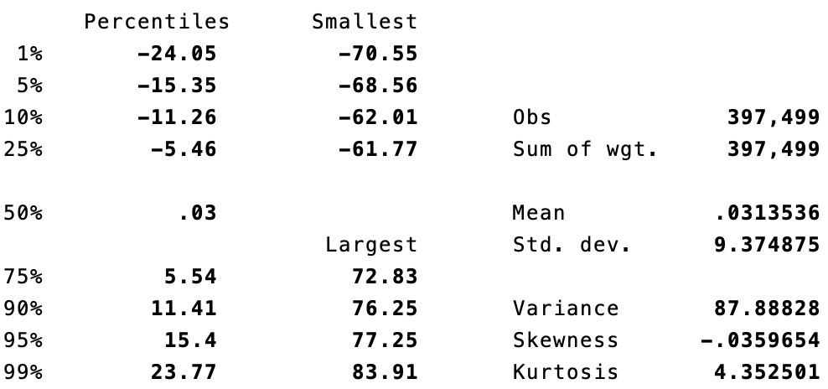

Descriptive Statistics for Migration as Percent of Population in County in Year of Observation:

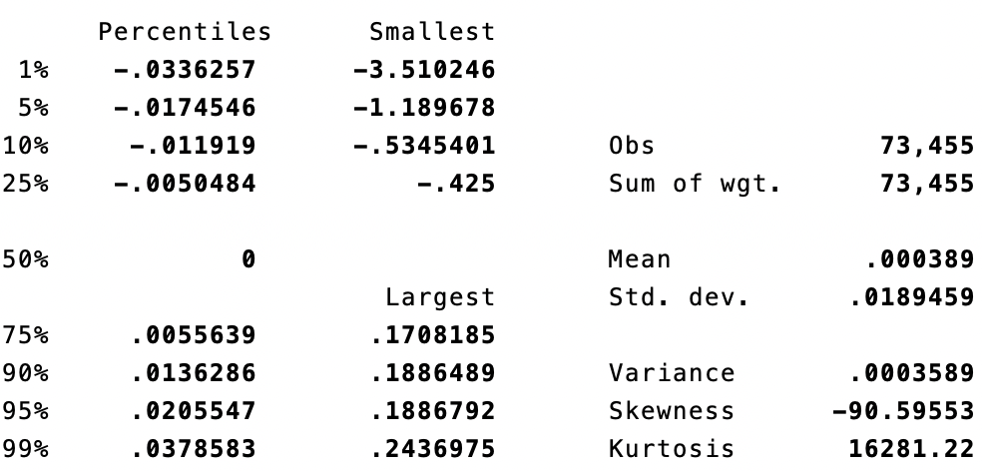

**Scatter Plot Between Precipitation and Migration**

